*LTM (Local Travel Mate)*

Namwoo Kim  
knw0809@gmail.com

United UK

Abdullaev Farkhodjon

abdullaevfarhodjon@gmail.com

United UK

Habibilloh Erkinov

habibilloherkinov@gmail.com

United UK

***Abstract- Over recent years, tourism is one of the fastest developing industry that is contributing enormously to the growth of countries’ economy all over the world. In such a fast moving industry the needs for a kind of tour guides that can be local hosts or kinds of mobile applications websites are growing day by day. Considering all about this, we decided to make a software application (LTM Local Travel Mate) that stands for the tourists’ needs as a kind of online travel mate. The LTM application is made for all kinds of users to provide an assistance for those who like to travel all over the world. According to many tourists’ and locals’ points of view, people who are traveling to some countries want to meet and make local friends from that host country and also locals like to meet foreigners. However, it is a little difficult because not having proper kind of mobile application to make foreign and local friends when you visit to some country because of not knowing their culture, language, and the like. In this paper we will explain about our project LTM (Local Travel Mate) which serves as a kind of tour guide and communication tool along with its technicals and usage. The introduction part will define more clearly about the application*. (***Abstract***)**

# I INTRODUCTION

1. Overview

Nowadays, millions of tourists from diverse countries usually are making travel to different countries every year for different purposes. Most of them go somewhere for study, business purposes, tourist attractions, nature beauty and so on. However, everytime being a foreigner is not easy and almost every time huge amount of travelers face some problems due to transportation, language barrier, hotels, foods, travel infos, tourist attractions, restaurants and so on when they visit to some country as a guest. Based on tourists’ requirements, we decided to make an application(LTM) for travelers to reduce their barriers when they visit to some country.

2. Objectives

The main purpose of this application (LTM) is to build a bridge between the locals of host countries and the tourists who are traveling all around the world. Nowadays, most countries are paying much of their attention on the development of tourism and involving immigrants for their countries in order to diffuse their culture and history of their development all over the world. However, sometimes it is a little difficult for some people who wants to travel to some country due to suffering from some kind of problems like not having enough information about the country that they want to visit and not having any acquaintances there. In addition, there is also a problem among some counties’ locals to meet and make foreign friends in their host countries because not having such kind of communication tool that is attached only for tourists and locals. After consideration all of this condition we started working on our project which can be a kind of solution for this problems.

3. System Structure

Local Travel Mate (LTM) has several useful functions those can be handy for the users like country select and get information function, users’ post board, pick up travel schedule and chat activity. People who are going to travel to some country can use our application as a tour guide by selecting the country that they want to visit and get all informations about the country like the culture of the country, language, tourist attractions, hotels, foods and so on. And also they will be able to meet some friends from that host country that they want to visit by using the chat function of the application. And they can post latest news or updates from their trips to some country or involve other foreigners to their country by posting the most common tourist attraction places to the news board.

## II SYSTEM DEVELOPMENT ENVIRONMENT AND TOOLS

1. Android Development Tool

To develop this application, Java programming language is selected meanwhile it was needed AVD to debug the program. Android Studio was chosen as an android application development tool recommended by Google. We used JDK tool to finish the Java programming.

B. Android Studio

Android Studio is a “fairly new IDE (Integrated Development Environment) made available for free by Google to Android developers”, it is “based on IntelliJ IDEA, an IDE that also offers a good Android development environment” (Govender 2014) [1]. Compared with Eclipse, Android Studio has better startup time, response speed and memory usage. What’s more, it has smarter editor which absorbs advantages of Eclipse and ADT, and has real-time preview of interface as well. Studio also supports every plugin, such as Git, Markdown and Gradle. Fig.1 presents the interface of Android Studio.

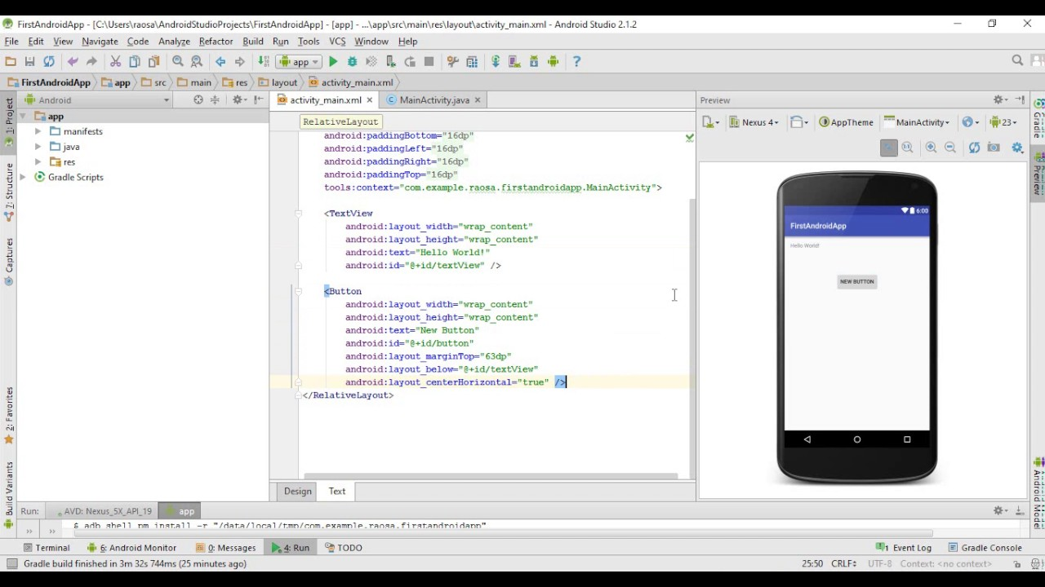

Fig.1 Interface of Android Studio

C. Android SDK and JDK

Android SDK is “the Android Software Development Kit contains the necessary tools to create, compile and package Android applications”, and “the primary way to develop Android applications is based on the Java programming language”. Every programming language has its own SDK, and it is available for various languages. The SDK for Java is called JDK, the Java Development Kit, which is included in SDK.

D. Java Programming Language

Java programming language is “designed to have the ‘look and feel’ of the C++language”. It “can be used to create complete applications that may run on a single computer or be distributed among servers and clients in a network”, and “build a small application module or applet for use as part of a Web page”. Java has the following major characteristics. Firstly, programs

created by Java are portable in network [1]. The source program compiled into with Java is bytecode, it can be run both on a server or a Java virtual machine. Secondly, Java code is “robust” because of its safety inspection rule. Thirdly, Java is object-oriented which is easier than C++.

E. Firebase Non-relational Database System

For developing this Mobile application Firebase is non relational database system is needed to store the user information, provide authorization and supply communication between users.

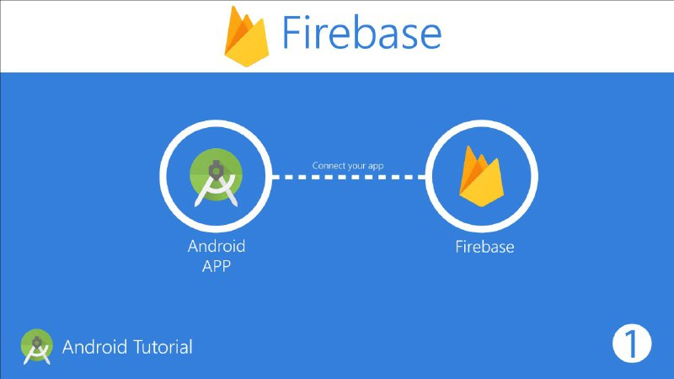

Fig.2 Firebase Non-relational Database

### III ANALYSIS OF LOCAL TRAVEL MATE(LTM)

1. Requirement Analysis

Requirement Analysis is the process of determining the user expectations from the new application. According to our research, there are some features needed to add and be improved in the current existing tour guide applications. Before designing our application, we searched all about tour guide applications and find out some features are missing in most of them. According to our find outs, the most common features those are missing on that applications are like recommended trips, share your travel, find out and make local friends and so on.

After consideration all of those requirements for the new application, we decided to design and build our own application that fills some of those requested features of users from upcoming new tour guide application LTM. We designed to add Travel Infos function that user can get some informations about the country that they want to visit. And we add User Post Board function that all users of the application can share their travel experiences with others. Furthermore, we add chat function for the application that users can use it to make friends locally or by distance.

In order to use the application with these new features, login function with the valid password should be taken by the users, and the system should be able to manage and maintain all users accounts.

1. System Analysis

The use case diagrams are the methodologies used in system analysis to identify, clarify and organize the system requirements. Based on requirement analysis, the case diagram for authorizing user is drawn as Figure 3.

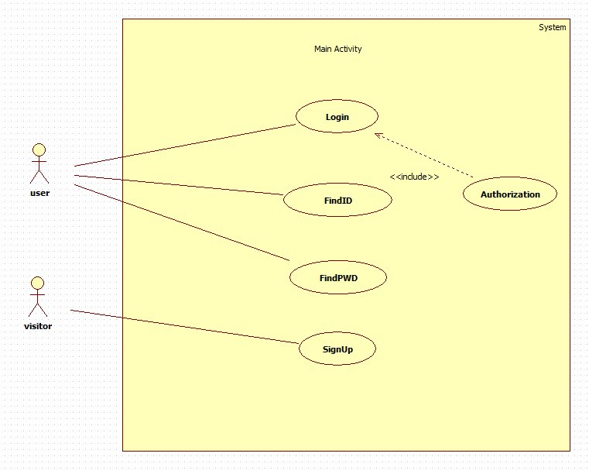

Fig.3 Use case diagram for Authorizing Users

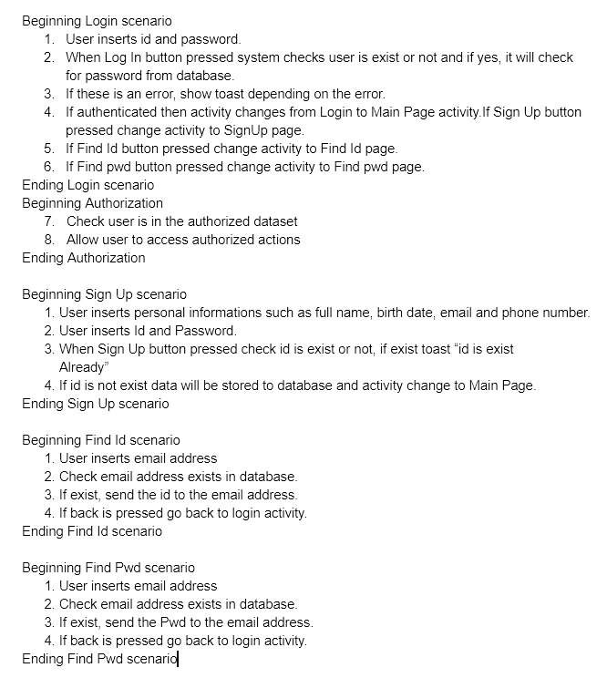

Fig.4 The use case Scenario for Authorizing User

The two figures above shows the process of authorizing users in database and system. Authorized user will be able to go to the main page of the application. In the main page, there is the select country function that user choose any country on the list and get information about that country. Figure 5 and 6 shows the use case diagram and scenario for select country function.

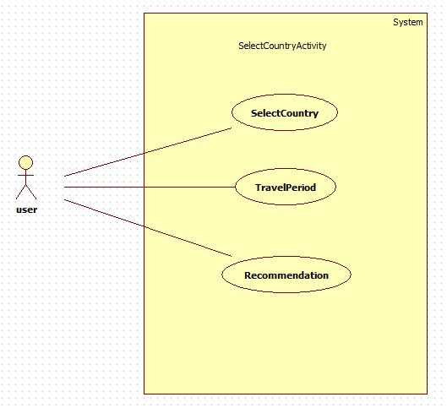

Fig.5 Use case diagram for Select Country

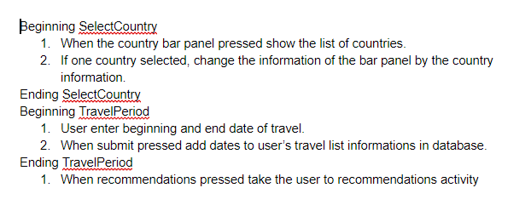

Fig.6 Use case scenario for Select Country

Another functionality of the application is user Post Board that gives to all authorized users to share their own travel experiences by uploading their photos or comments to the News Board. The use case diagrams and scenario for the news board function are as follows.

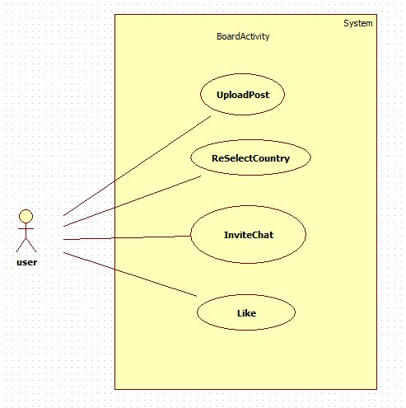

Fig.7 Use case diagram for users Post Board

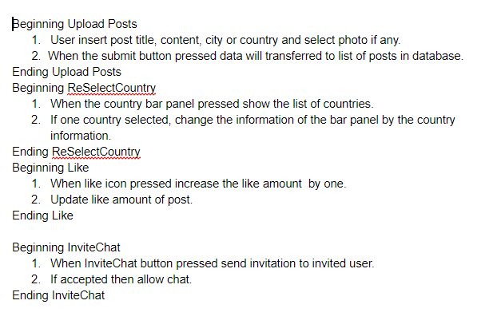

Fig.8 Use case scenario for users Post Board

The fourth functionality of our application is users chat page that all authorized users can go to the chat page and use it to make local and foreign friends. The figures below shows the use case diagram and scenario for the chat function.

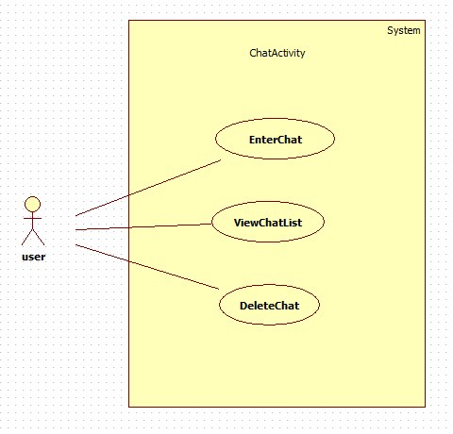

Fig.9 Use case diagram for Chat Function

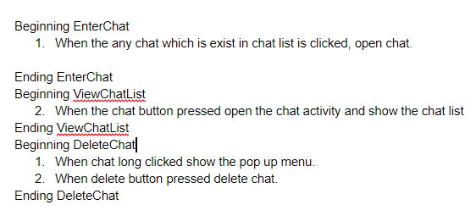

Fig.10 Use case scenario for Chat Function

IV RELATED WORKS

According to our research, there are are many various android system based tour guide applications on the Play Market and App Stores available with its guidelines. We tried to choose some of those application models as a related work to our designed application.

PSiS is a tour planning support system that aims to provide the tourist a visit plan combining, in a tour, the most adequate tourism products, namely interesting places to visit, attractions, restaurants and accommodation, according to tourists' specific profile (which includes interests, personal values, wishes, constraints and disabilities)[2]. Functioning and transportation schedules are also

considered to generate a tour planning. Before the trip a tourist interacts with the system through the special web application

and during the trip it is possible to use the special mobile application for Android-based smartphones.

GuidiGO Personal world-wide tour guide. It allows to get an experience about destination, by downloading guided tours created by local experts and passionate storytellers around the world. It is possible to choose a tour based on the tourist interests:

history, architecture, art, fashion, etc[2].

Go!Tour[3] Android-based mobile application for providing tourism and geographic services in Istanbul city. Application has internal attraction database and provides possibilities of searching places of interests around using the Variable Neighborhood-based

algorithm.

TripAdvisor Millions of traveler reviews, photos, and maps can be accessible in TripAdvisor. Tourists can plan their trips taking into account over 100 million reviews and opinions by travelers. TripAdvisor makes it easy to find the lowest airfare, best hotels, great restaurants, and fun things to do, wherever you go. The mobile application is free, it supports all mobile platforms[4]. http://www.tripadvisor.ru

Smart Travelling Online travel guide that supports about 30 cities worldwide including the most interesting destinations in European countries and USA. The guide includes a database of restaurants, cafes, hotels, shopping-tips and other places of interests. The mobile application for iPhone is accessible in AppStore. Integration with Google maps allows user to see the current location in the map and helps to navigate to each and every tip in destination cities. Application allows the user to download the content and use guide without Internet connection[4]. http://www.smart-travelling.net/en/

V TESTED RESULTS

### 

In this section, we will present the working flow of Local Travel Mate android operating system based smartphone application. So until now, the coding part of the application is completed successfully. Now, the LTM local travel mate is ready to be tested. In this part of the paper we will show the results of tested application on android smartphone with functions order. The orders are as follow:

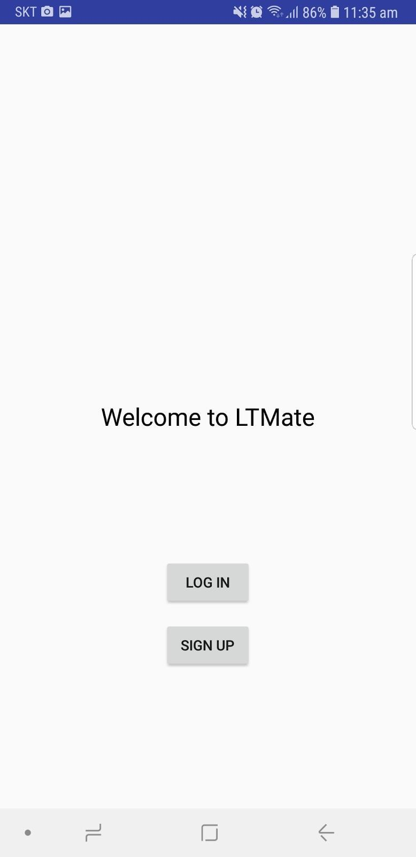

Fig.11 Welcome Page with LogIn and SignUp buttons.

After installing the application, user will be directed to welcoming page which has login and sign up button and also forgot password label. If user is new for this application they can sign up or login or reset their password by going to sign up, login or forgot password page using two buttons and label which we mentioned before.

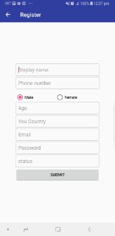

Fig.12 User Registration Page

In this page the new user of the application can register him or herself to the system and real time database. In order to register, the user needs to enter the correct email address and valid password as well as trustfull information about his or herself. The registered user can immediately go to the main page of the application.

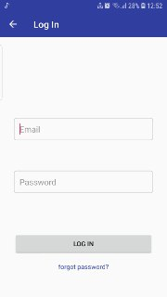

Fig.13 LogIn Page

Authorized user can re login to his or her profile in this page if he or she logged out by intention.

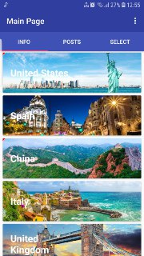

Fig.14 Main Page

Authorized users will be turn to select country page where they will be faced to list of countries after they choose the country for travel, they will require to insert the travel date which are entry and departure dates (inserting travel date is for only tourists).

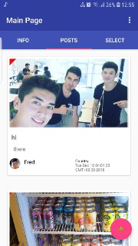

Fig.15 User Post Board

Application provide board page which allows users to upload posts about that they are traveling some countries and looking for local people who live in that countries or hosts who want to invite tourists to their area by uploading images and information about the place

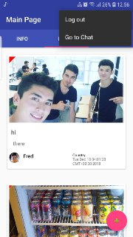

Fig.16 Go to Chat Page

From here user can go the chat page

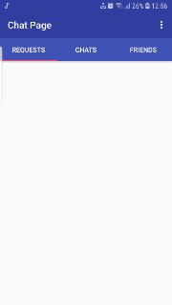

Fig.17 Main Chat Page

In this page users will be able to manage their friends list or chats and can receive or reject friend requests.



Fig.18 Chat List

Here the user can manage his/her chat list.

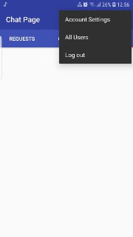

Fig.19 Items Bar

In this item bar users can go to account settings and can modify their profiles. And they will be able to see all users of the application or easily can log out their profile.

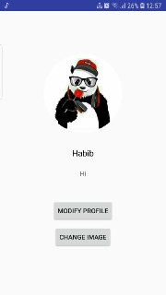

Fig.20 Account Setting

There is Modify profile or change image buttons in the account settings. If users want to change their personal information or travel dates, they can modify it from their profile page.

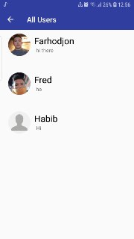

Fig.21 All users Page

In this page users will be able to make friends by sending friend requests and they can view all users profile.

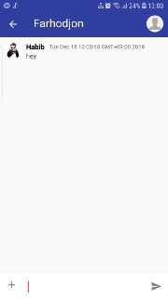

Fig.22 Main chat page

Chat page is one of the most useful facilities for users which have been provided by this application. Chat page has three fragment inner pages which are requests, chats and friends pages. If a tourist or host find some useful information on board page, they can easily contact with the person who upload the post by sending friend request to him or her. If request is accepted they will be added friend lists of each-other. Then they can open chat room and communicate in here.

# VI CONCLUSION

In summary, the definition and the demonstration of the application shows that, it will be a widely used mobile app among the people as a kind of communication tool as well as being a very good tour guide for the users. The application brings more comforts for the user with its easy usage to understand and easy to find information about the country that the user wants to travel. The user can select any country that he/she wants to travel and get the information about that country's culture, tradition, the touristic attractions, foods, hotels, living expenses and so on. As well as getting information the country before they visit, they will be able to find some friends there those can be guides for them on that targeted country. Furthermore, users or the guides of the host countries can post their good memories or tourist attractions in the news board of the application to attract more people to their country and improve the tourism.

##### VII REFERENCES

**[1]. Mi Hu & Yu Weng Bachelor’s Thesis School of Business and Culture Degree Programme in Business Information Technology Bachelor of Business Administration 2016.**

**[2]. R. Anacleto, L. Figueiredo, A. Almeida, P. Novais, Mobile application to provide personalized sightseeing tours, Network and**

**Computer Applications, vol. 41, 2014, pp. 56-64.**

**[3]. K. Al-Rayes, A. Sevkli, H. Al-Moaiqel, H. Al-Ajlan, K. AlSalem,**

**N. Al- Fantoukh, “A Mobile Tourist Guide for Trip Planning”, IEEE Multidisciplinary Engineering Education Magazine, vol. 6, no. 4, Dec 2011, pp. 1-6.**

**[4]. K. Luyten and K. Coninx, “ImogI: Take Control over a Context**

**Aware Electronic Mobile Guide for Museums”, HCI in Mobile Guides, University of Strathclyde, Glasgow, September 2004.**